**DEPARTMENT OF COMPUTER SCIENCE AND ENGINEERING**

**DBMS PROJECT SUBJECT CODE : CO-202**



**SUBMITTED BY :**

NAME : Sudhanshu ( 2K22/CO/457) Suryaansh Tomar ( 2K22/CO/461)

Hitansh (2K22/CO/212)

**Proff. Rohit Beniwal**

# PROJECT

**E-LEARNING PLATFORM MANAGEMENT SYSTEM**

**Introduction**

##### Problem Statement :

The rapid growth of e-learning platforms has created a demand for efficient and scalable database management systems to handle the vast amount of user- generated content. These platforms need to manage diverse data types, including user profiles, courses, enrollments, and assignments, all while ensuring data integrity, security, and quick access. The challenge is to design a database system that can support the dynamic interactions of millions of users, handle real-time data updates, and provide reliable performance.

##### Motivation :

The motivation behind this project is to understand and address the complexities involved in managing a large-scale social networking platform. Such platforms are integral to modern communication and community building, s t u d e n t s across the globe. By working on this project, we aim to:

•

•

•

Gain practical experience in database design and implementation. Understand the real-world applications of database management systems in handling large volumes of data.

Explore optimization techniques to enhance the performance and scalability of the database.



**Objective :**

1. **Designing a Scalable Schema**: Develop a database schema that efficiently handles various data entities such as users (students , instructors ), assignments etc
2. **Ensuring Data Integrity**: Implement constraints and relationships to maintain data integrity and consistency across the database.
3. **Optimizing Performance**: Utilize indexing, normalization, and query optimization techniques to ensure quick data retrieval and update operations.
4. **Supporting User Interactions**: Enable functionalities such as user registration, posting assignments, comments, etc
5. **Providing Security and Privacy**: Implement security measures to protect user data and ensure privacy.



**System Requirements :**

User registration and authentication Student Profile management Course information

Instructor information

Assignment Notifications



**The Database for the e-learning management system will have the following tables:**

1. **Students**: Storing student information (ID, name, email, date of birth).
2. **Instructors**: Storing instructor information (ID, name, email).
3. **Courses**: Storing course information (ID, name, description, instructor ID).
4. **Enrollments**: Tracking student enrollments in courses (ID, student ID, course ID, enrollment date).
5. **Assignments**: Storing assignment details for courses (ID, course ID, title, description, due date).

#### Entities and Attributes:

* + **Students**: StudentID (PK), FirstName, LastName, Email, DateOfBirth
  + **Instructors**: InstructorID (PK), FirstName, LastName, Email
  + **Courses**: CourseID (PK), CourseName, CourseDescription, InstructorID (FK)
  + **Enrollments**: EnrollmentID (PK), StudentID (FK), CourseID (FK), EnrollmentDate
  + **Assignments**: AssignmentID (PK), CourseID (FK), AssignmentTitle, AssignmentDescription, DueDate

#### Relationships:

* + **Students** to **Enrollments**: One-to-Many
  + **Courses** to **Enrollments**: One-to-Many
  + **Instructors** to **Courses**: One-to-Many
  + **Courses** to **Assignments**: One-to-Many

**ER Diagram Description**

## Students Table:

* + Primary Key: **StudentID**
  + Other Attributes: **FirstName**, **LastName**, **Email**, **DateOfBirth**

## Instructors Table:

* + Primary Key: **InstructorID**
  + Other Attributes: **FirstName**, **LastName**, **Email**

## Courses Table:

* + Primary Key: **CourseID**
  + Foreign Key: **InstructorID**
  + Other Attributes: **CourseName**, **CourseDescription**

## Enrollments Table:

* + Primary Key: **EnrollmentID**
  + Foreign Keys: **StudentID**, **CourseID**
  + Other Attributes: **EnrollmentDate**

## Assignments Table:

* + Primary Key: **AssignmentID**
  + Foreign Key: **CourseID**
  + Other Attributes: **AssignmentTitle**, **AssignmentDescription**, **DueDate**

**ER DIAGRAM**

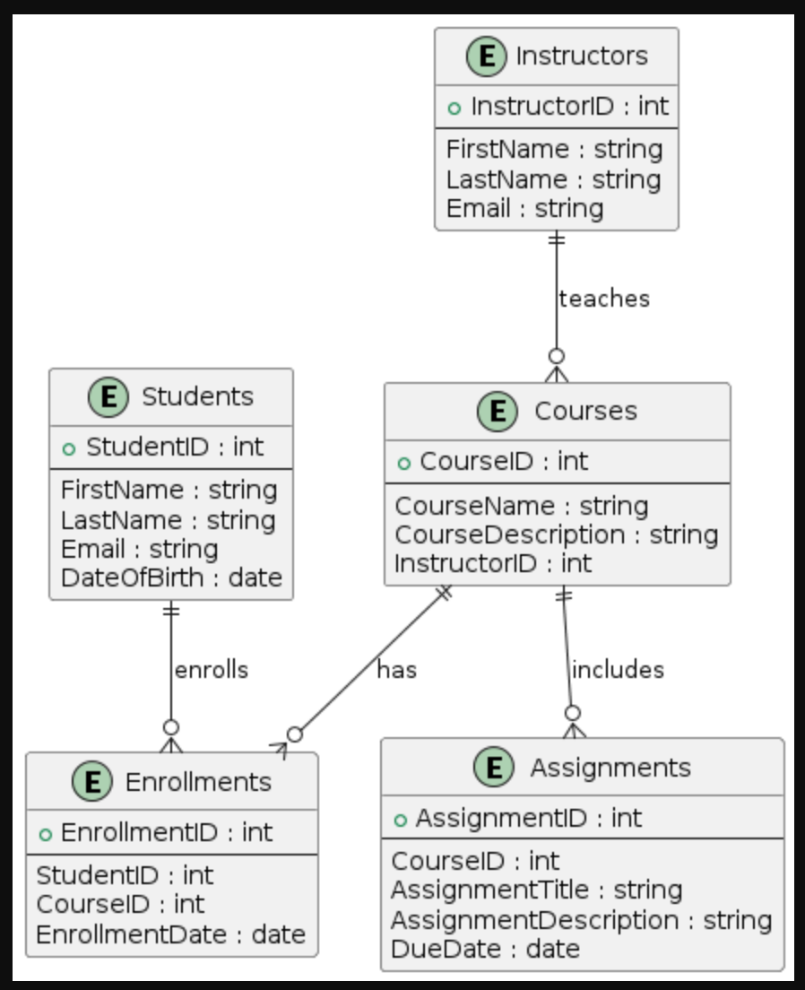

**Implementing the DDL and DML commands**

Creation of Tables :

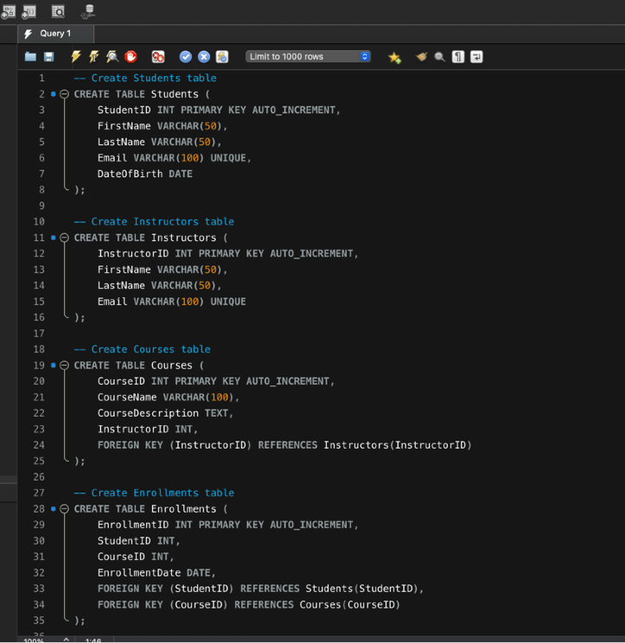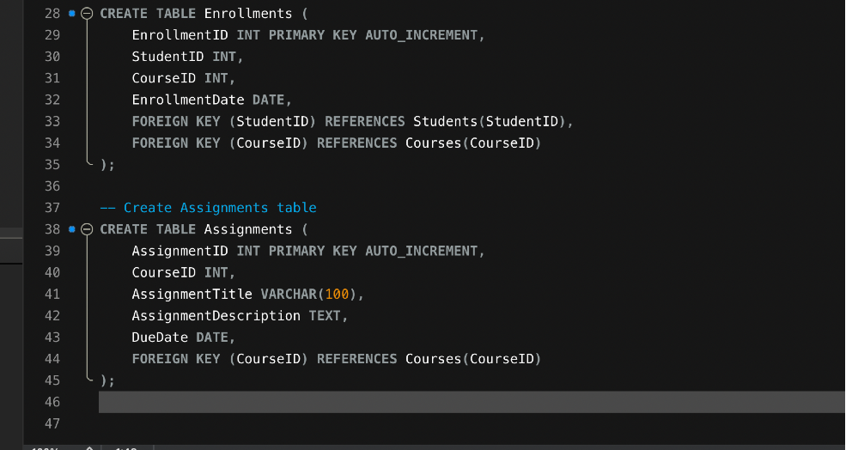

Insertion of data into respective tables :

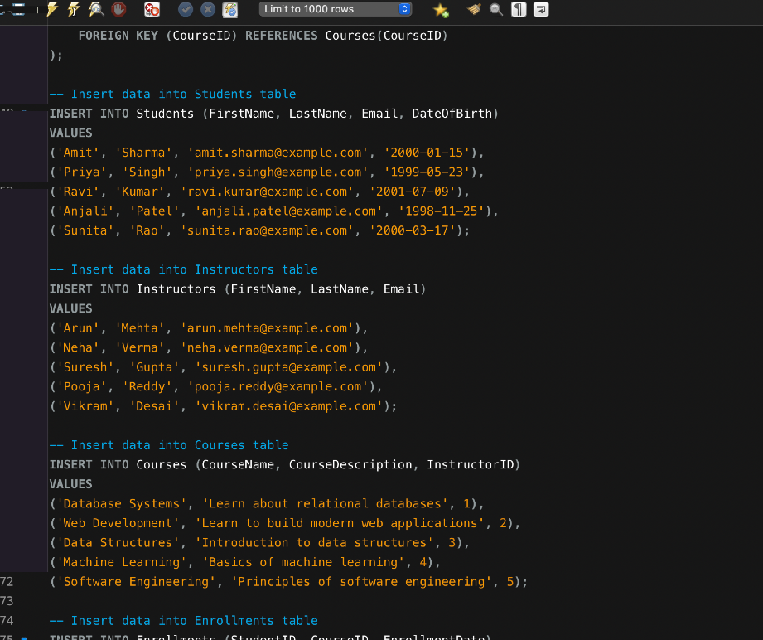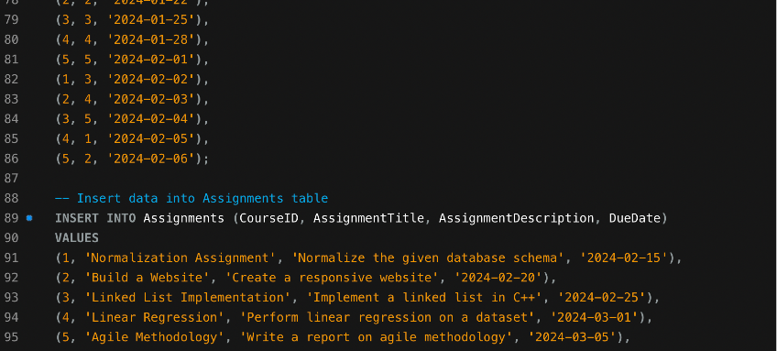

**Queries On Joins And Aggregate functions**

1. **Retrieve all students with their enrolled courses**

List of Students Enrolled in Each Course SELECT

Courses.CourseName, Students.FirstName, Students.LastName

FROM

Enrollments JOIN

Students ON Enrollments.StudentID = Students.StudentID JOIN

Courses ON Enrollments.CourseID = Courses.CourseID ORDER BY

Courses.CourseName, Students.LastName, Students.FirstName;

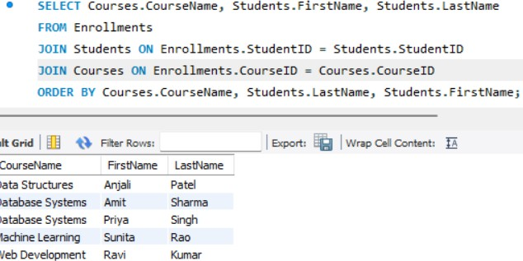

•2. Count the number of students enrolled in each course

Count of Students Enrolled in Each Course

SELECT

Courses.CourseName,

COUNT(Enrollments.StudentID) AS NumberOfStudents FROM

Courses LEFT JOIN

Enrollments ON Courses.CourseID = Enrollments.CourseID GROUP BY

Courses.CourseName ORDER BY

NumberOfStudents DESC;

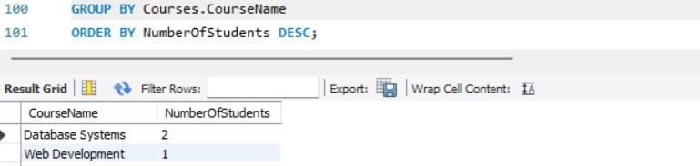

**3. List of Courses Along with Their Instructor's Name**

SELECT

Courses.CourseName, Instructors.FirstName, Instructors.LastName

FROM

Courses JOIN

Instructors ON Courses.InstructorID = Instructors.InstructorID ORDER BY

Courses.CourseName;

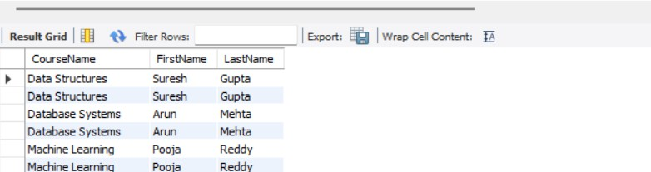

**4. Number of Assignments per Course**

SELECT

Courses.CourseName,

COUNT(Assignments.AssignmentID) AS NumberOfAssignments FROM

Courses LEFT JOIN

Assignments ON Courses.CourseID = Assignments.CourseID GROUP BY

Courses.CourseName ORDER BY

NumberOfAssignments DESC;

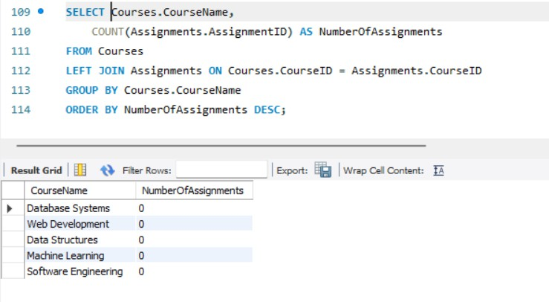

**5. Detailed Enrollment Information (Student, Course, and Instructor)**

SELECT

Students.FirstName AS StudentFirstName, Students.LastName AS StudentLastName, Courses.CourseName,

Instructors.FirstName AS InstructorFirstName, Instructors.LastName AS InstructorLastName, Enrollments.EnrollmentDate

FROM

Enrollments JOIN

Students ON Enrollments.StudentID = Students.StudentID JOIN

Courses ON Enrollments.CourseID = Courses.CourseID JOIN

Instructors ON Courses.InstructorID = Instructors.InstructorID ORDER BY

Students.LastName, Students.FirstName, Courses.CourseName;

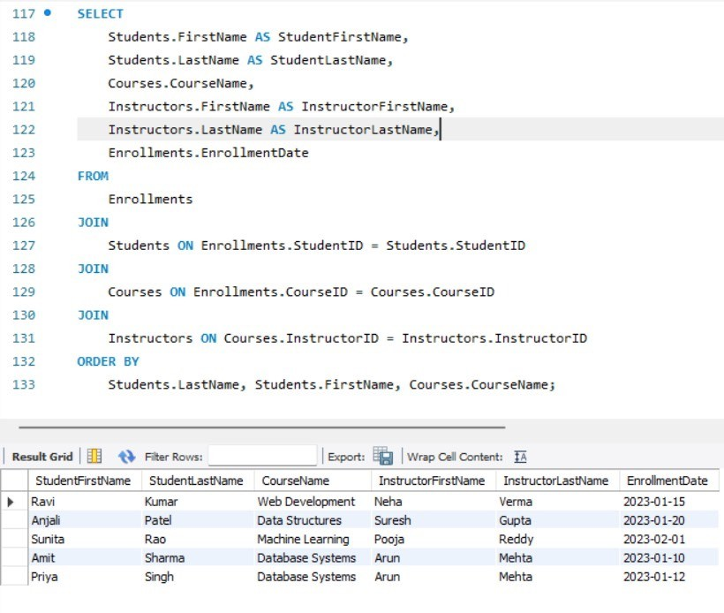

### Students with the Most Enrollments

**SELECT**

**Students.FirstName, Students.LastName,**

**COUNT(Enrollments.CourseID) AS TotalEnrollments**

**FROM**

**Students JOIN**

**Enrollments ON Students.StudentID = Enrollments.StudentID GROUP BY**

**Students.StudentID ORDER BY**

**TotalEnrollments DESC;**

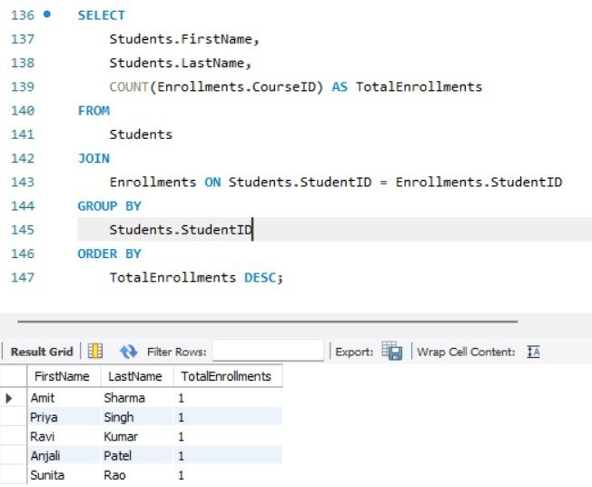

**FUTURE SCOPE:**

1. **Enhanced Features and Functionality Advanced User Interactions**:

Implement interactive dashboards for students and instructors with real-time updates and notifications.

Add features like peer reviews, collaborative projects, and group discussions to foster a more interactive learning environment.

**Gamification**:

Introduce gamification elements such as badges, points, and leaderboards to motivate and engage students.

Create interactive quizzes and challenges with immediate feedback to enhance learning engagement.

1. **Data Analytics and Insights**

**Course Effectiveness**:

Analyze course completion rates, student feedback, and performance data to assess the effectiveness of courses and instructors.

Use insights to continuously improve course content and instructional methods.

**Sentiment Analysis**:

Apply natural language processing (NLP) techniques to analyze student and instructor feedback, discussion forums, and reviews.

1. **Scalability and Performance Database Optimization**:

Optimize database queries, indexing, and partitioning to handle increasing amounts of data and users efficiently.

Implement data archiving strategies to maintain performance as historical data grows.

**Cloud Integration**:

Utilize cloud-based infrastructure to ensure scalability, reliability, and high availability of the platform.

Leverage cloud services for storage, computing, and database management to accommodate growing user bases.

1. **Security Enhancements Data Privacy and Compliance**:

Implement robust data encryption and secure access controls to protect sensitive student and instructor information.

Ensure compliance with data protection regulations like GDPR, FERPA, and other relevant standards.

**Real-Time Monitoring and Alerts**:

Deploy real-time monitoring tools to detect and respond to security incidents, performance issues, and system anomalies.

Set up automated alerts for suspicious activities, potential breaches, and system failures.

**User Authentication and Authorization**:

Enhance security with multi-factor authentication (MFA) and single sign-on (SSO) solutions.

Implement role-based access control (RBAC) to ensure appropriate access levels for students, instructors, and administrators.

### CONCLUSION:

The development of an e-learning management DBMS project offers significant potential to transform educational experiences by leveraging advanced features, robust data analytics, and scalable architecture. By incorporating enhanced user interactions, personalized learning paths, and gamification elements, the platform can create an engaging and dynamic learning environment. Advanced data analytics and insights will enable educators to make data-driven decisions, improving course effectiveness and student performance.

Scalability is ensured through database optimization, cloud integration, and microservices architecture, allowing the system to grow with the increasing demands of users. Additionally, stringent security measures will protect sensitive data and maintain user trust.

Overall, this e-learning management DBMS project promises to be a comprehensive, secure, and scalable solution that not only meets current educational needs but also adapts to future advancements and challenges. By continuously innovating and integrating new technologies, the platform can significantly enhance the learning and teaching experience, paving the way for a more effective and inclusive education system.

•